MONTANA ACADEMY OF OPHTHALMOLOGY – EYE M.D.S
PO Box 794 • Helena, Montana 59624 • (406) 443-1570 Voice • www.montanaeyemds.org

November 22, 2021

Dear Exhibitor:

The 2022 Big Sky Regional Ophthalmology CME Conference sponsored by the Montana Academy of Ophthalmology will be Sunday, February 6 – Tuesday, February 8 at the Yellowstone Conference Center in Big Sky, Montana. We invite you to participate.

The Montana Academy of Ophthalmology is still completing the CME process, but wanted to ensure our exhibitors had ample time to plan on joining us in Big Sky. As soon as we have final approval for our CME, I will follow-up with detailed topic, agenda and presenter information.

The Exhibit Hall will be available to exhibitors for setup Sunday afternoon. The conference exhibit hall will open to physician participants at 7am Monday morning.

A block of sleeping rooms is available for conference registrants. Reservations for rooms must be made directly with Big Sky’s Huntley Lodge. Their reservation telephone number is 406-995-5000 or 1-800-548-4486. You can view the different accommodation options at Big Sky Hotels.

After receiving much positive feedback from Exhibitors in previous years, the Montana Academy of Ophthalmology will again offer booth fees at different price points to fit the needs and size of your company. Review the Gold, Silver, and Bronze Exhibitor options and determine which works best for you. Please fill out the attached registration form and send it, along with payment, to the Montana Academy of Ophthalmology. Please note the new mailing address: PO Box 794, Helena, MT 59624.

If you need me to complete a form or on-line application for the exhibit booth fee, please let me know.

If you have attended in the past, the conference this year will be very similar. If you have never attended a Montana Academy of Ophthalmology CME, please call with any questions or concerns you might have. It is a great opportunity to connect with about half of the Ophthalmologists in Montana.

Sincerely,

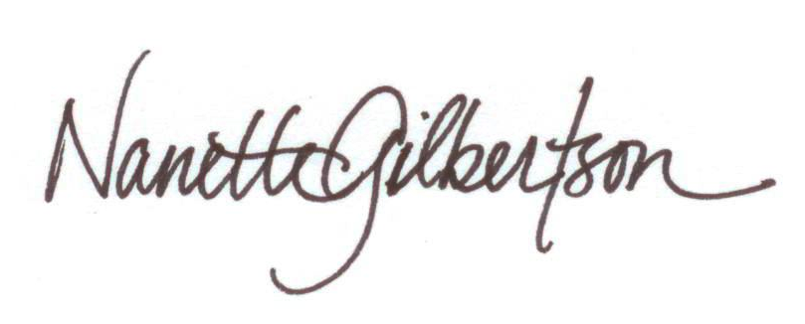
Nanette Gilbertson
Executive Director

MONTANA ACADEMY OF OPHTHALMOLOGY – EYE M.D.S
PO Box 794 • Helena, Montana 59624 • (406) 443-1570 Voice • www.montanaeyemds.org

2022 Big Sky Regional Ophthalmology CME Conference
Sponsored by the Montana Academy of Ophthalmology

BIG SKY, MONTANA
YELLOWSTONE CONFERENCE CENTER

FEBRUARY 6-8, 2022

EXHIBITOR INFORMATION and REGISTRATION FORM

If you have questions or concerns, contact Nanette (406-443-1570 or nanette@smithandmcgowan.com).

Please legibly complete the registration form, make checks payable to the Montana Academy
of Ophthalmology, and mail to:

Nanette Gilbertson, Executive Director
Montana Academy of Ophthalmology
PO Box 794
Helena, Montana 59624

e-mail: nanette@smithandmcgowan.com

MAO Federal Tax ID Number: 36-3872740

SET UP TIME: 1:30 PM - 5 PM. SUNDAY, FEBRUARY 9, 2020

LABEL AND MAIL EQUIPMENT TO:
Make sure to indicate it’s for the Ophthalmology Conference

Attn: Conference Mgr.
Big Sky Resort
1 Lone Mountain Trail
Big Sky, Montana 59716-0001
“HOLD FOR OPHTHALMOLOGY CONFERENCE”
Telephone: 1-800-548-4487

SLEEPING ROOM RESERVATIONS:
A block of sleeping rooms is available for conference registrants. Reservations for rooms must be made directly with Big Sky’s Huntley Lodge. Their reservation telephone number is 406-995-5000 or 1-800-548-4486. You can view the different accommodation options at Big Sky by going to these links: (https://bigskyresort.com/hotels or https://bigskyresort.com/lay-of-the-land). To receive the conference discount, be sure to specify that you are with the Montana Academy of Ophthalmology meeting.

Make your sleeping room accommodations as soon as possible. The room block expires January 1, 2022 or when full, whichever occurs first!

As a reminder, in order to receive the discounted ski lift ticket price, you have to book your sleeping room reservations directly through Big Sky Central Reservations (as opposed to a VRBO type situation).

REGISTRANT INFORMATION

Company Name

Address

City State Zip

Email Telephone

Representative(s) Attending

Representative’s Mailing Address

City State Zip

Email Telephone

Exhibitor Options
Please check (✓) one exhibitor option

☐ $2,500 Gold Exhibitor
3 Exhibit Representatives. Acknowledgement in the MAO Annual Meeting Materials. Access to MAO membership list for promotional purposes. Option to place an article in one of the quarterly MAO E-Newsletters. One (1) 6’ display table w/ chairs. Breakfast on Monday and Tuesday and cocktail party Monday evening included for up to three (3) Representatives. Electronic mailing list of attendees.

☐ $1,500 Silver Exhibitor
2 Exhibit Representatives. Acknowledgement in the MAO Annual Meeting Materials. One (1) 6’ display table w/ chairs. Breakfast on Monday and Tuesday and cocktail party Monday evening included for up to two (2) Representatives. Electronic mailing list of attendees.

☐ $ 750 Bronze Exhibitor
1 Exhibit Representative. Acknowledgement in the MAO Annual Meeting Materials. One (1) 6’ display table w/ chairs. Breakfast on Monday and Tuesday and cocktail party Monday evening included for up to one (1) Representatives. Electronic mailing list of attendees.

PAYMENT

$___________ TOTAL

Payment Type: ☐Check Enclosed ☐Credit Card ☐Payment in Process

Credit Card Type: ☐Visa ☐Master Card ☐Discover ☐American Express
Credit Card #_______________-_______________-_______________-_______________
Exp. Date ___________/___________ CVV Code _________ Billing Zip____________
Signature _________________________________________ Date _________________

